Sri Lanka Institute of Information Technology



# Comprehensive Design Analysis Project

# **AI Solution to assist online education productivity via personalizing learning strategies and analyzing the student performance**

# Project Id: 2022-017

Logbook

IT19120812

Liyanage M.L.A.P.

10th of November 2022

Table of Content

1. Our journey 3
2. Screenshots of MS team and Chats 5

# Our Journey

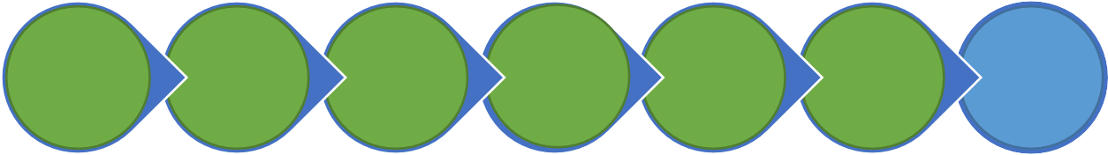

**Workshop &**

**Supervisor Selection**

**Project pre-**

**assessments (Topic Evaluation)**

**Project**

**Proposal Presentation**

**Progress**

**Presentation - 1**

**Progress**

**Presentation - 2**

**Demo &**

**Poster**

**Final**

**Presentation & Viva**

We are Here Now

|  |  |  |
| --- | --- | --- |
| **Event** | **Date/Time** | **Summery** |
| Workshop & Supervisor Selection | December - January | Created a team with 4 members. Did some research on what domain we should start our final year research. Selected Prof. Samantha Thelijjagoda as our supervisor and Co-supervisor as Ms. Archchana Kugathhasan. Mr. Koliya Harshanath joined as the external supervisor.  We selected our research topic as Machine learning based personalized education platform. Then we registered our research topic. |
|  |  |
| Project pre-assessments (Topic Evaluation)  &  Project proposal presentation | December - January | We referred existing research papers on the chosen domain and identified the research gap with current systems that are in the market. Created a project proposal document with guidance of supervisor, external supervisor and co- supervisor.  The presented the proposal to the panel, and it got accepted. |

|  |  |  |
| --- | --- | --- |
|  | January 10 and 24 | Completed System architecture design and data gathering phases. Initial model implemented. |
| Progress Presentation – 1 | April 8 – 6.00am  – 7.30am | Had a meeting with the external supervisor to discuss the progress of the implementations. |
| May 12 | Model implementations completed.  Frontend initialized with basic functionalities and integrated with backend |
| 14th May 2022 | By the time of progress presentation 1, completed 75% of the work of career path identification model and job recommendation engine. |
| Progress Presentation - 2 | 11th and 13th of October | By the time of progress presentation 2, implementations are completed by 90%. Research paper is accepted by UEMCON  Created a poster for the presentation. |

|  |  |  |
| --- | --- | --- |
|  | November 6 - 12 | Had some meetings to finalize the system. Did some unit testing and integration testing. Did some improvements to increase the accuracy of  the model.  Fixed identified bugs.  Application Deployed to the cloud. |

* 1. Screenshots of MS team and Chats



